# Testing

## 1-What is Testing

**# Source**: **Chatgpt (GPT-5-Standard) at [8/12/2025]**

In **software engineering**, **testing** is the process of evaluating a software application or system to find defects (bugs), verify that it works as intended, and ensure it meets the specified requirements before it is delivered to users.

In simpler terms:  
 It’s like a **quality check** for software — making sure it does what it’s supposed to do, works reliably, and doesn’t break in unexpected ways.

## 2-Main Goals of Software Testing

**# Source**: **Chatgpt (GPT-5-Standard) at [8/12/2025]**

1. **Verify functionality** – Does the software do what the requirements say?
2. **Detect defects** – Find and fix bugs before users encounter them.
3. **Ensure quality** – Improve reliability, performance, and usability.
4. **Validate requirements** – Confirm the product matches the client’s needs.

## 3-Types of Software Testing

**# Source**: **Chatgpt (GPT-5-Standard) at [8/12/2025]**

**1. Based on Approach**

* **Manual Testing** – Humans perform tests without automation tools.
* **Automated Testing** – Scripts and tools automatically run tests.

**2. Based on Purpose**

* **Functional Testing** – Checks *what* the system does.  
   Example: Unit Testing, Integration Testing, System Testing, Acceptance Testing.
* **Non-Functional Testing** – Checks *how well* the system works.  
   Example: Performance Testing, Security Testing, Usability Testing.

## 4-Testing Stages in Development

**# Source**: **Chatgpt (GPT-5-Standard) at [8/12/2025]**

1. **Unit Testing** – Test small, individual pieces of code.
2. **Integration Testing** – Test how different parts work together.
3. **System Testing** – Test the complete application as a whole.
4. **Acceptance Testing** – Final check before release, often done with the customer.

💡 **Key Point:** Testing doesn’t guarantee software is 100% bug-free — it reduces the risk of defects and increases confidence that the system will work correctly in real use.

## 5-why there are Software testing

**# Source**: **Chatgpt (GPT-5-Standard) at [8/12/2025]**

Software testing exists because humans (and the code we write) are far from perfect — and mistakes in software can cost money, damage trust, or even endanger lives.

Here’s a clear breakdown:

### I. Why There Is Software Testing

**# Source**: **Chatgpt (GPT-5-Standard) at [8/12/2025]**

We test software to:

1. **Find bugs before users do** – Prevent crashes, incorrect results, or security holes.
2. **Ensure it meets requirements** – Verify that what was built matches what was asked for.
3. **Improve reliability** – Confirm the software works under expected (and unexpected) conditions.
4. **Reduce risks** – Catch issues that could cause legal, financial, or safety problems.
5. **Maintain quality over time** – Prevent new updates from breaking existing features.

Think of it as the “quality checkpoint” before letting software go into the wild.

### II. How Software Testing Was Discovered / Made

**# Source**: **Chatgpt (GPT-5-Standard) at [8/12/2025]**

Software testing wasn’t born as a formal concept — it evolved as computers became complex:

* **1940s–1950s** – Early computers were programmed on punch cards; errors were so costly in time that programmers checked outputs manually.
* **1960s** – With the rise of larger systems, IBM and others began formalizing debugging and verification methods.
* **1970s–1980s** – “Software engineering” became a field; structured testing methods (unit, integration, system testing) were documented.
* **1990s–2000s** – Automated testing tools emerged as software grew bigger and release cycles got shorter.
* **Today** – Testing is part of **SDLC** (Software Development Life Cycle) and **CI/CD pipelines**, using automation, AI-based testing, and continuous monitoring.

### III. How We “Make” Software Testing

**# Source**: **Chatgpt (GPT-5-Standard) at [8/12/2025]**

We *create* testing strategies and methods by:

1. **Defining what to test** – Based on requirements, user stories, or risk assessment.
2. **Choosing test types** – Unit tests, integration tests, system tests, UI tests, performance tests, security tests, etc.
3. **Designing test cases** – Step-by-step checks of inputs, actions, and expected results.
4. **Automating where possible** – Using tools like Selenium, JUnit, or Playwright.
5. **Measuring coverage** – Ensuring all important paths and edge cases are checked.
6. **Iterating** – Updating tests as software changes.

## 6-is testing need management

**# Source**: **Chatgpt (GPT-5-Standard) at [8/12/2025]**

Yes — **software testing absolutely needs management**, and in fact, there’s an entire discipline called **Test Management** dedicated to it.

### Why Testing Needs Management

**# Source**: **Chatgpt (GPT-5-Standard) at [8/12/2025]**

Without management, testing can become:

* **Unorganized** → tests may be missed or duplicated.
* **Inefficient** → testers spend time on low-priority areas while critical parts go unchecked.
* **Unmeasurable** → no way to know if you’re truly ready for release.

### What Test Management Involves

**# Source**: **Chatgpt (GPT-5-Standard) at [8/12/2025]**

1. **Planning** – Deciding the scope, objectives, resources, and schedule for testing.
2. **Organizing** – Assigning roles and responsibilities (testers, tools, environments).
3. **Controlling** – Monitoring progress, managing risks, and making adjustments.
4. **Tracking & Reporting** – Measuring results (bug counts, coverage, pass rates) and sharing them with stakeholders.

### Benefits of Test Management

**# Source**: **Chatgpt (GPT-5-Standard) at [8/12/2025]**

* **Clear priorities** – Focus on what matters most.
* **Better coverage** – Reduce the risk of missing critical defects.
* **Efficient use of resources** – Right people, right tools, right time.
* **Transparency** – Everyone knows the status of testing and readiness for release.

💡 *In professional projects, Test Management is usually handled by a* ***Test Manager*** *or* ***QA Lead****, often using tools like Jira, TestRail, or Zephyr to coordinate and track testing activities.*

## 7-what is testing tools

**# Source**: **Chatgpt (GPT-5-Standard) at [8/12/2025]**

**Testing tools** are **software applications** or platforms that help testers **plan, execute, manage, and automate** the testing process.  
 They make testing faster, more accurate, and more organized compared to doing everything manually.

### 1. Why We Use Testing Tools

**# Source**: **Chatgpt (GPT-5-Standard) at [8/12/2025]**

* **Save time** – Automate repetitive checks.
* **Improve accuracy** – Reduce human error.
* **Track progress** – Measure coverage, pass/fail rates, bug counts.
* **Handle complexity** – Test large systems or multiple platforms efficiently.

### 2. Types of Testing Tools & Examples

**# Source**: **Chatgpt (GPT-5-Standard) at [8/12/2025]**

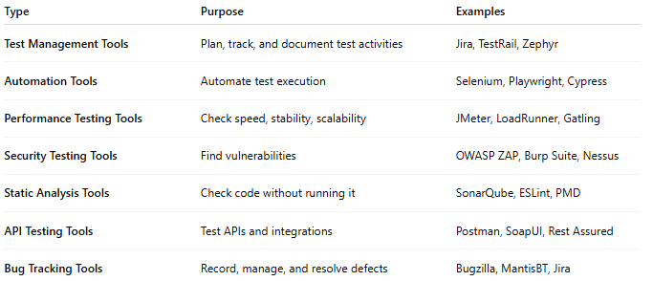

| **Type** | **Purpose** | **Examples** |
| --- | --- | --- |
| **Test Management Tools** | Plan, track, and document test activities | Jira, TestRail, Zephyr |
| **Automation Tools** | Automate test execution | Selenium, Playwright, Cypress |
| **Performance Testing Tools** | Check speed, stability, scalability | JMeter, LoadRunner, Gatling |
| **Security Testing Tools** | Find vulnerabilities | OWASP ZAP, Burp Suite, Nessus |
| **Static Analysis Tools** | Check code without running it | SonarQube, ESLint, PMD |
| **API Testing Tools** | Test APIs and integrations | Postman, SoapUI, Rest Assured |
| **Bug Tracking Tools** | Record, manage, and resolve defects | Bugzilla, MantisBT, Jira |

### 3. Where Testing Tools Fit in the Process

**# Source**: **Chatgpt (GPT-5-Standard) at [8/12/2025]**

* **Static Testing Phase** → Static analysis tools (e.g., SonarQube)
* **Dynamic Testing Phase** → Automation, performance, security tools
* **Management Phase** → Test management and bug tracking tools

## 8-Essentials Skills and Good practices in Testing

**# Source**: **Chatgpt (GPT-5-Standard) at [8/12/2025]**

Here’s a compact but complete breakdown of **Essential Skills** and **Good Practices** in software testing, so it’s easy to apply in real projects.

### 1. Essential Skills in Testing 🛠️

#### Technical Skills

**# Source**: **Chatgpt (GPT-5-Standard) at [8/12/2025]**

* **Understanding of SDLC & STLC** → Know how testing fits in software development and testing life cycles.
* **Test Design Techniques** → Equivalence partitioning, boundary value analysis, decision tables, state transition testing, etc.
* **Automation Skills** → Using tools like Selenium, Cypress, Playwright, JUnit, or Postman.
* **Knowledge of Databases** → Basic SQL queries to validate backend data.
* **API Testing** → Understanding REST, SOAP, JSON, XML, and how to verify them.
* **Debugging & Troubleshooting** → Ability to pinpoint root causes with logs, breakpoints, and error messages.

#### Analytical Skills

**# Source**: **Chatgpt (GPT-5-Standard) at [8/12/2025]**

* **Requirement Analysis** → Spot ambiguities, missing details, and inconsistencies.
* **Risk Analysis** → Identify high-priority areas that must be tested thoroughly.

#### Soft Skills

**# Source**: **Chatgpt (GPT-5-Standard) at [8/12/2025]**

* **Attention to Detail** → Catching subtle defects that others might miss.
* **Communication** → Writing clear bug reports and test documentation.
* **Critical Thinking** → Asking “what if” and exploring edge cases.
* **Team Collaboration** → Working effectively with developers, product managers, and other testers.

### 2. Good Practices in Testing ✅

**# Source**: **Chatgpt (GPT-5-Standard) at [8/12/2025]**

1. **Start Testing Early**
   * Follow *Shift-Left Testing* — involve testers in requirements and design phases.
2. **Write Clear Test Cases**
   * Each case should have a clear objective, steps, expected result, and actual result.
3. **Test Based on Risk**
   * Focus more on features that are critical to business or prone to failure.
4. **Automate Where Useful**
   * Automate repetitive regression tests, but keep exploratory testing manual.
5. **Use Realistic Test Data**
   * Avoid only using dummy values; simulate real-world usage as much as possible.
6. **Log Bugs Clearly**
   * Include steps to reproduce, screenshots, and environment details.
7. **Maintain a Test Environment**
   * Keep it stable and close to production conditions.
8. **Measure and Improve**
   * Track metrics like defect density, test coverage, pass/fail rate to identify improvement areas.
9. **Perform Exploratory Testing**
   * Go beyond scripted tests to find unexpected issues.
10. **Retest and Regression Test**
    * Always recheck fixed defects and ensure new changes haven’t broken existing functionality.

## 9-Whole Team Approach

**# Source**: **Chatgpt (GPT-5-Standard) at [8/12/2025]**

**Whole Team Approach** in testing means **everyone involved in the software development project shares responsibility for quality** — not just the testers or QA team.

Instead of thinking “testing is the tester’s job,” the whole team (developers, testers, business analysts, product owners, designers, etc.) collaborates to **prevent defects early** and **ensure the product meets quality goals**.

### Key Points

**# Source**: **Chatgpt (GPT-5-Standard) at [8/12/2025]**

* **Quality is a shared responsibility**, not a separate phase at the end.
* Testing activities are integrated throughout the **Software Development Life Cycle (SDLC)**.
* Encourages **communication** between roles to detect issues early.
* Fits naturally into **Agile and DevOps** workflows.

### Example

**# Source**: **Chatgpt (GPT-5-Standard) at [8/12/2025]**

Imagine you’re building an **online shopping cart**:

* **Business Analyst**: Clearly defines requirements and acceptance criteria.
* **Developer**: Writes code and also writes automated unit tests.
* **Tester**: Designs exploratory and functional test cases.
* **UX Designer**: Ensures the interface is intuitive and tests prototypes with users.
* **Product Owner**: Reviews features and gives feedback early.
* **DevOps Engineer**: Sets up continuous integration and testing pipelines.

All of them **work together**, give feedback, and adjust before the software is released.

### Benefits

**# Source**: **Chatgpt (GPT-5-Standard) at [8/12/2025]**

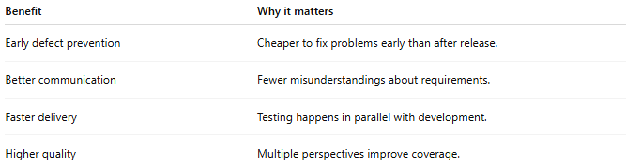

| **Benefit** | **Why it matters** |
| --- | --- |
| Early defect prevention | Cheaper to fix problems early than after release. |
| Better communication | Fewer misunderstandings about requirements. |
| Faster delivery | Testing happens in parallel with development. |
| Higher quality | Multiple perspectives improve coverage. |

💡 **In short**:  
 Whole Team Approach = “It’s **our** product, so it’s **our** quality responsibility.”

If you like, I can also explain **how Whole Team Approach connects with “Independence of Testing”** — they seem opposite at first but actually complement each other.

## 10-Independence of Testing

**# Source**: **Chatgpt (GPT-5-Standard) at [8/12/2025]**

**Independence of Testing** means that the people who test the software should be **as separate as possible from the people who developed it** — to avoid bias and catch more defects.

When developers test their own code, they might:

* Assume it works as intended (confirmation bias).
* Overlook defects because they know “how it’s supposed to work.”
* Skip testing unusual scenarios.

Independent testers bring **fresh eyes** and a **different perspective**, which increases the chance of finding issues.

### Levels of Testing Independence (from least to most independent)

**# Source**: **Chatgpt (GPT-5-Standard) at [8/12/2025]**

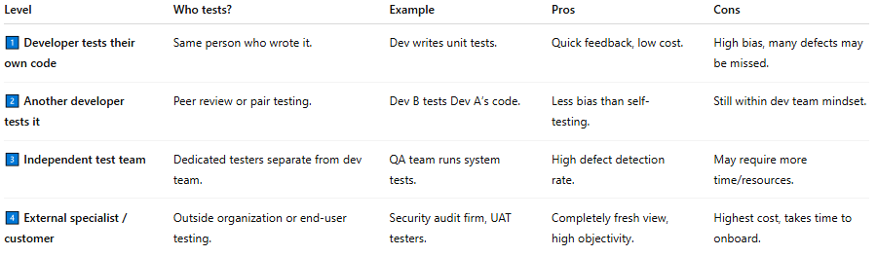

| **Level** | **Who tests?** | **Example** | **Pros** | **Cons** |
| --- | --- | --- | --- | --- |
| 1️⃣ **Developer tests their own code** | Same person who wrote it. | Dev writes unit tests. | Quick feedback, low cost. | High bias, many defects may be missed. |
| 2️⃣ **Another developer tests it** | Peer review or pair testing. | Dev B tests Dev A’s code. | Less bias than self-testing. | Still within dev team mindset. |
| 3️⃣ **Independent test team** | Dedicated testers separate from dev team. | QA team runs system tests. | High defect detection rate. | May require more time/resources. |
| 4️⃣ **External specialist / customer** | Outside organization or end-user testing. | Security audit firm, UAT testers. | Completely fresh view, high objectivity. | Highest cost, takes time to onboard. |

### **Example**

**# Source**: **Chatgpt (GPT-5-Standard) at [8/12/2025]**

If you build a login feature:

* **Not independent**: You code it and test it yourself.
* **More independent**: Your teammate tests it.
* **Fully independent**: A QA tester who wasn’t involved in coding tests it.

✅ **Key Idea**:  
 The more independent the testing, the better the chances of catching hidden defects — but the higher the cost and effort.